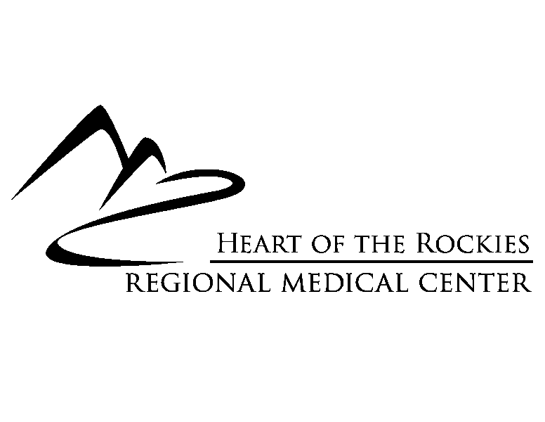

P.O. Box 429
1000 Rush Drive
Salida, CO 81201
719-530-2200

NOTICE

The regularly scheduled meetings of the Board of Directors of Salida Hospital District d/b/a Heart of the Rockies Regional Medical Center for the fourth calendar quarter of 2025 will occur on each of the following dates at 1:00 p.m. at the locations identified:

Tuesday, October 28th – Shavano Conference Room or Remote Meeting via Zoom
*Tuesday, November 25th – Shavano Conference Room or Remote Meeting via Zoom
*Tuesday, December 23^{rd –} Shavano Conference Room or Remote Meeting via Zoom

Future meeting schedules will be posted on a quarterly basis.
Copied:
Members of the Board of Directors
HRRMC Senior Administrative Team
Posted on October 1, 2025 at/with:
- In the atrium at the Hospital, 1000 Rush Drive
- Hospital’s website at www.hrrmc.com

*Note: Meeting dates are subject to change from their customary 4th Tuesday to allow time for completion and presentation of next year’s budget

